How to sign up and create an account as a customer:

1. Go to the home page (<http://localhost:8080/Inkredible/index.html>)
2. Click on the Login button at the top right of the page



1. Select customer login

1. Click “New Customer signup!”



1. Fill out your information
2. When complete click on “here” to return to the customer login page



How to log in as a customer:

1. Starting at the home page (<http://localhost:8080/Inkredible/index.html>).
2. Click on the Login button at the top right of the page



1. Select customer login

1. Enter your information

How to view information about your appointments and select new a new appointment.

Starting at your account home page (<http://localhost:8080/Inkredible/customerHomePage.jsp>) you should automatically see any appointments that you have at the top.

This will show you date, time, your username, the artist’s ID that you will have, and the total cost of the work done.

To update the time of day enter your username and a new Date and time in the format Month Day, Year, Houram/pm.

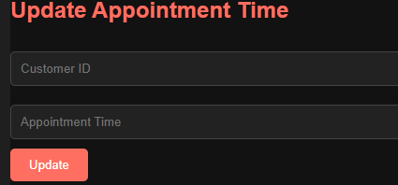



To select a new available appointment, select an appointment from the dropdown menu and hit select. (To see any changes, you will need to sign in again).

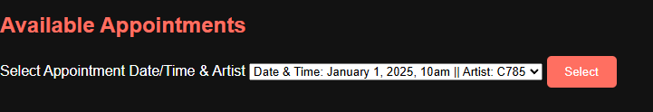  
  
  
To see your account information click on the account button on the left.



Here you can see your current account information like username password, first and last name, and email address.

You are also able to change any of the information that you would like except your username. All you need to do is fill out the information you wish to change and click on submit change (To see any changes, you will need to sign in again).

By clicking on logout your information will be removed from the session, and you will be sent back to the home page.



How to log in as an artist:

1. Starting at the home page (<http://localhost:8080/Inkredible/index.html>).
2. Click on the Login button at the top right of the page



1. Select customer login



1. Enter your information

At your home screen you will see all your assigned appointments (including appointments that have not been claimed by customers).

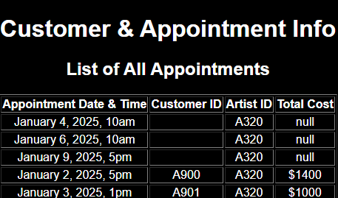

By using the select customer drop down you can filter between specific customers that have an appointment with you.

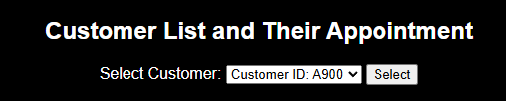

Here you can see all their appointments with you as well as any appointments they have / had at the shop.

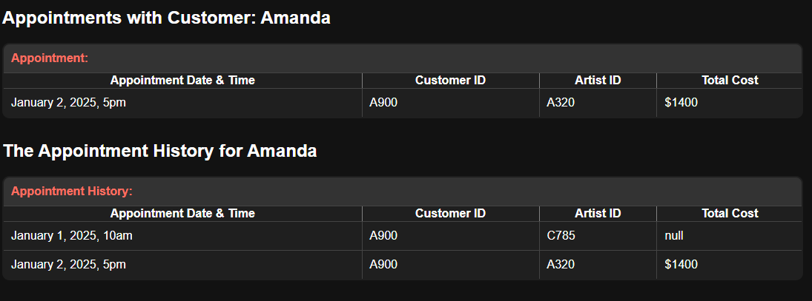

To change the cost of an appointment use the update appointment cost form at the bottom of you artist home page.

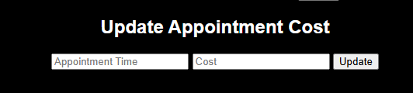

Here just type in the appointment date / time and cost as so and click update.



To see your account information click on the artist account details button on the left.



Here you can see your current account information like username password, first and last name, email address, and style.

You are also able to change any of the information that you would like except your username. All you need to do is fill out the information you wish to change and click on submit change (To see any changes, you will need to sign in again).

By clicking on logout your information will be removed from the session, and you will be sent back to the home page.



How to log in as an admin:

1. Starting at the home page (<http://localhost:8080/Inkredible/index.html>).
2. Click on the Login button at the top right of the page



1. Select customer login



1. Enter your information

At your home page you will be able to register a new employee by filling out their information on the new employee registration form and clicking create.

You can also check an employees schedule by using the search at the bottom.

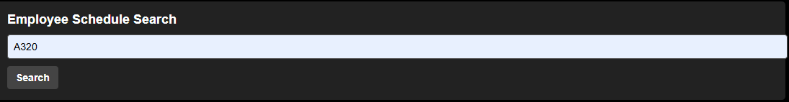

Here you can see id they work on specific days of the week by seeing true or false.

If true the artist works that day, if false the artist does not.

You can change the employees’ schedule at the bottom of the page by entering their artist id again for redundancy’s sake and changing the day of the week to true or false.

To see any changes search the employee again from your admin home page.

By clicking on logout your information will be removed from the session, and you will be sent back to the home page.



Other buttons on the site:

Clicking on the logo from anywhere will send you back to the home page.



Designs will take you to the design page showing the range of designs the shop is able to accommodate for.



Artists will take you to our artists’ page where you can read about all our artists and see some of their work and read about them.



Schedule will show you our current shop hours.



Reviews will take you to a page showing some reviews we have received from previous customers.

